**Exercise: DOM Manipulations**

Problems for exercises and homework for the ["JavaScript Advanced" course @ SoftUni](https://softuni.bg/courses/js-advanced)". Submit your solutions in the SoftUni judge system at <https://judge.softuni.bg/Contests/1550/Exercise-DOM-Manipulations>.

## Subtraction

An HTML page holds **two text fields** with ids "**firstNumber**" and "**secondNumber**". Write a function to **subtract** the values from these text fields and display the result in the **div** named "**result**".

**HTML and JavaScript Code**

Implement the aboveto provide the following functionality:

* Your function should take the values of "**firstNumber**" and "**secondNumber**", **convert** them to numbers, **subtract** the second number from the first one and then append the result to the **<div>** with **id="result"**.
* Your function should be able to work with **any 2 numbers** in the inputs, not only the ones given in the example.

**Example**

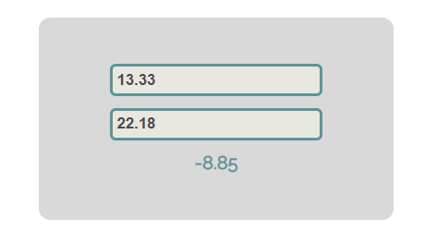

**Hints**

We see that the **textboxes** and the **div** have **id** attributes on them.  
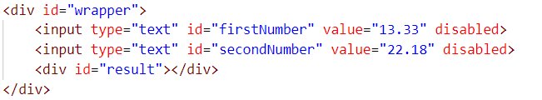

We can take the numbers directly from the input field by using the **getElementById()** function. After we have taken the elements from the DOM, it’s time to do the actual work. We get the values of the two **textboxes**, the value of a textbox, as one would expect, is **text**. In order to get a **number**, we need to use a function to **parse** **them**.



All that’s left now is to append the result to the **div**. We use the same function to get the **result** element by id and change its **text content** to the result of the **subtraction.**

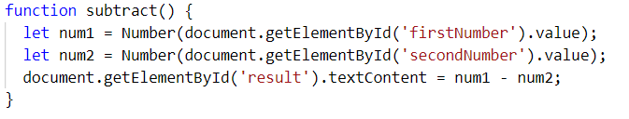

Our code is ready now. Submit only the **subtract()** function in judge.

## Fill Dropdown

Your task is to take values from **input** fields with **ids "newItemText"** and **"newItemValue"**.Then you should create and append an **<option>** to the **<select>** with **id** **"menu".**

**Example**

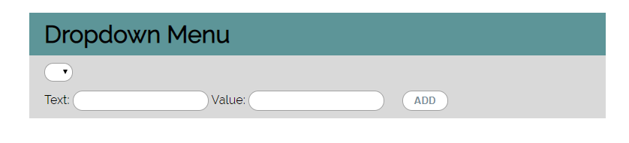

**Hints**

* Your function should take the values of **newItemText** and **newItemValue**. After that you should create a new **option** element and set its **textContent** and its **value** to the newly taken ones.
* Once you have done all of that, you should **append** the newly created **option** as a **child** to the **select** item with id **"menu".**
* Finally, you should **clear** the value of the two **input** fields.

## Accordion

An **html** file is given and your task is to show **more**/**less** information by clicking a **[ADD] button** (it is not an actual button, but a **span** that has an **onclick** event attached to it). When **[More] button** is clicked, it **reveals** the content of a **hidden** div and **changes** the text of the button to **[Less]**. When the same link is clicked **again** (now reading **Less**), **hide** the div and **change** the text of the link to **More**. Link action should be **toggleable** (you should be able to click the button infinite amount of times).

**Example**

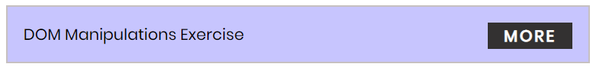

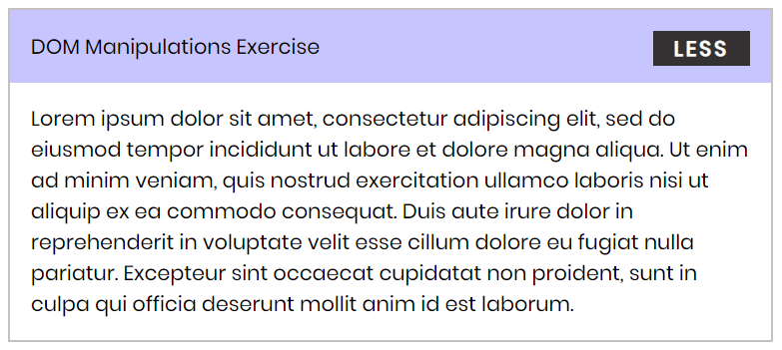

**Hints**

* To **change** the text content of a button, you could use **getElementsByClassName**. However, that returns a **collection** and we need only **one** element from it, so the correct way is to **use** **getElementsByClassName("button")[0]** as it will return the needed span element.
* After that we should change the **display style** of the div with an **id** "**extra**". If the display style is "**none**", we should **change** it to "**block**" and the **opposite**.
* Along with all of this, we should **change** the text content of the **button** to **[Less]**/[**More]**.

## Sections

You will receive an **array** of strings. For each string, create a **div** with a **paragraph** with the **string** in it. Each paragraph is initially **hidden (display:none)**. Add a **click** **event** **listener** to **each div** that **displays** the **hidden** paragraph. Finally, you should **append** all divs to the element with an **id** "**content**".

**Example**

 🡪 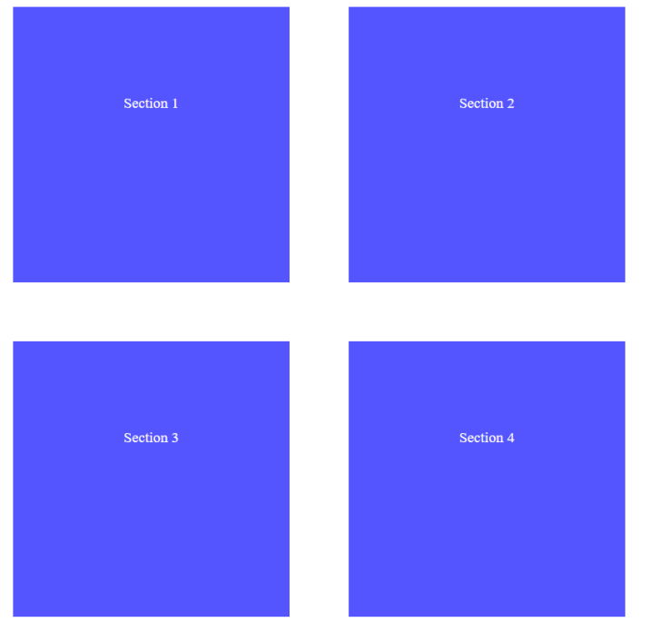

## Notification

Write a **function** that receives a string **message** and **displays** it inside a div with an id "**notification**" for 2 seconds. The div is initially **hidden** and when the function is called, it must be **shown**. After 2 seconds, **hide** the div. In the example below, a notification is shown when you **click** the button.

**Example**

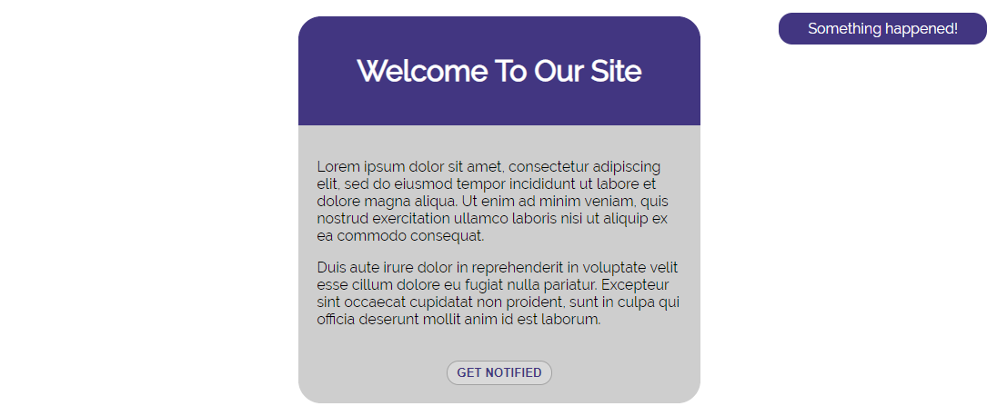

When we click the [**GET NOTIFIED**] **button**, a **div** appears in our upper-right corner. It should **disappear** in 2 seconds.

## Time Converter

Create a program that **converts** different time units. Your task is to add a **click** event listener to **all** [**CONVERT**] **buttons**. When a button is **clicked**, read the **corresponding** input field, **convert** the value to the **three other** time units and **display** it in the input fields.

**Example**

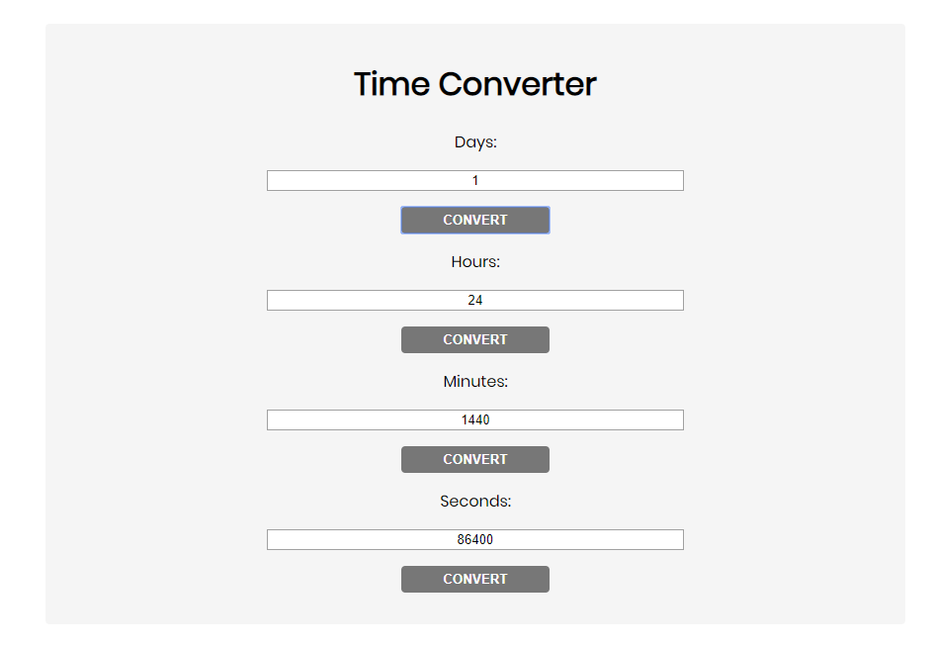

One day is equal to 24 hours/1440 minutes/86400 seconds. Whichever button we **click,** the input fields should **change** depending on the added value on the left. (For example, if we write 48 hours and click convert the days, the field value should change to 2).

## Locked Profile

In this problem, you should **create a JS functonality** which **shows** and **hides** the additional

information about users.

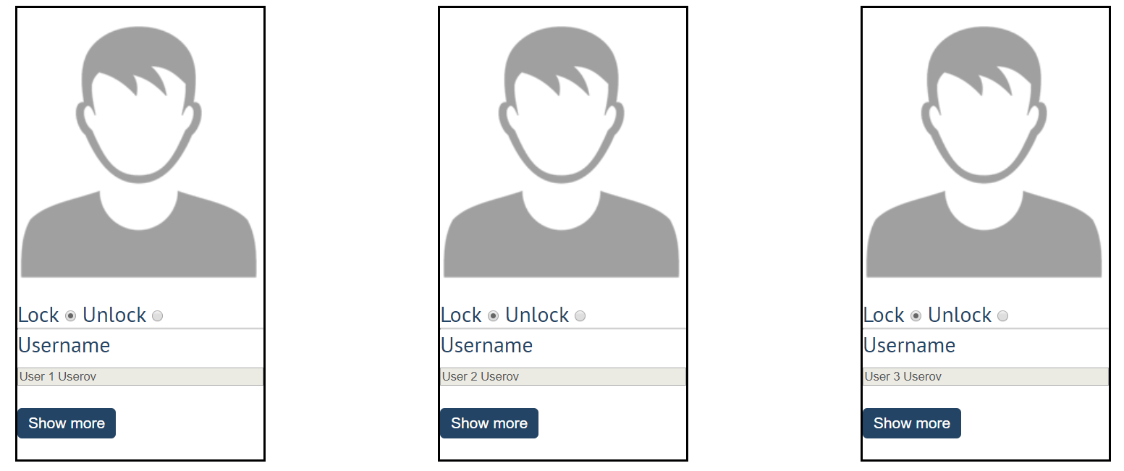

When one of the [**Show more**] **buttons** is clicked, the **hiden information** inside the div should

be shown, only if **the profile is not locked**! If the current profile is **locked,** nothing should

happen.

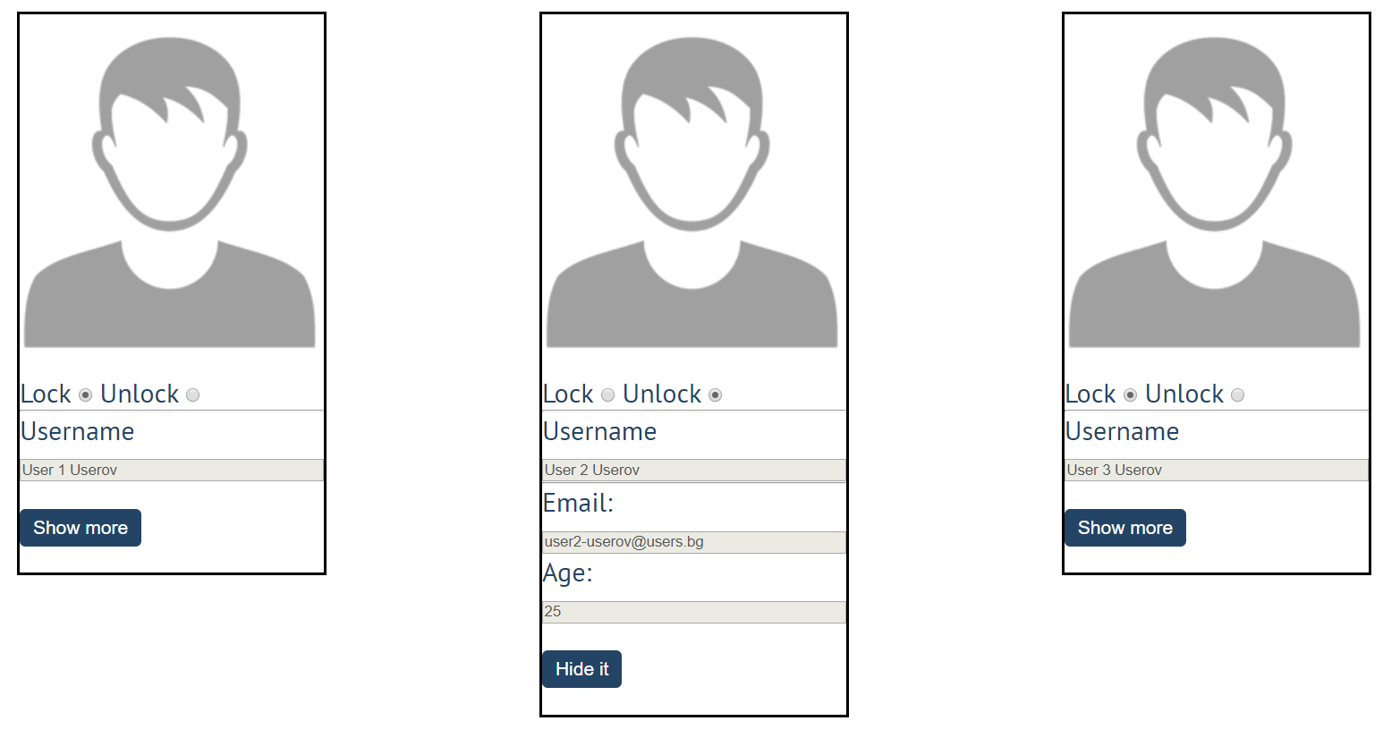

If the **hidden information is displayed** and we **lock** **the profile again**, the [**Hide it**] button

should **not be working**! Otherwise, when the profile is **unlocked** and we click on the **[Hide it]**

button, the new fields must hide again.

## Encode and Decode Messages

In this problem, you should **create a JS functonality** which **encodes and decodes some**

**messages which travel to the network.**

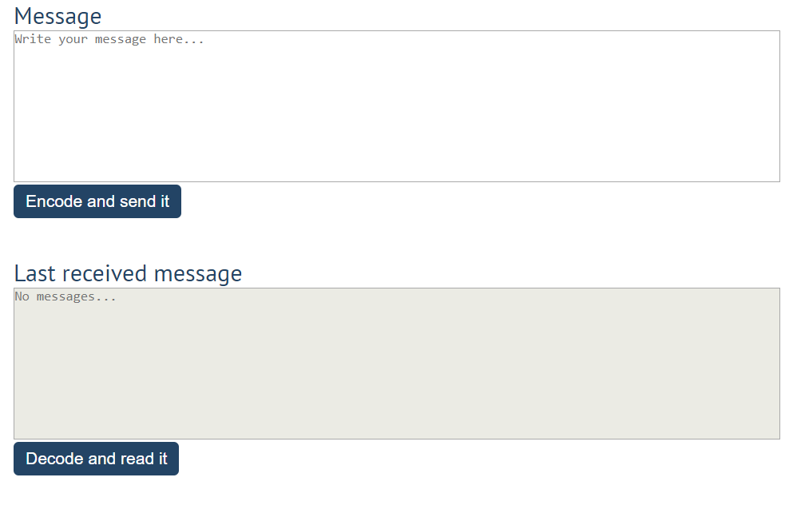

This program should contain **two functionalities**.

The first one is to **encode the given message** and **send it** to the **receiver**.

The second one is to **decode the received message** and **read it (display it)**.

When the [**Encode and send it**] **button** is clicked, you should get the given message from the first textarea. When you get the current message, you should encode it as follows:

* **Change** the **ASCII CODE** on **every single character** in that message when you **add 1** to the current **ASCII NUMBER**, that represent the current character in that message
* **Clear** the **sender** **textarea** and **append** the encoded message to the **receiver textarea**

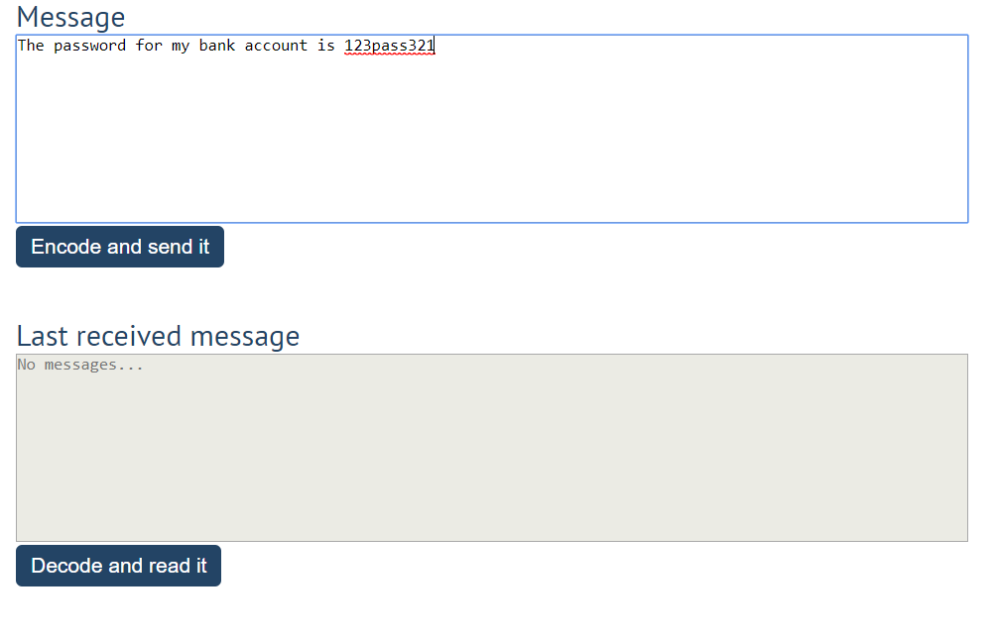

After clicking [**Encode and send it**] **button** the result should be:

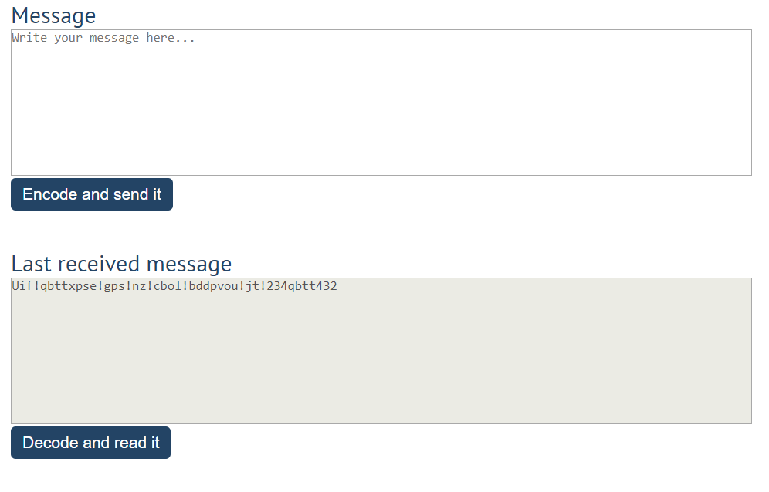

After that, when the [**Decode and read it**] **button** is clicked. You need to get the **encoded message** from **the receiver textarea** and do the **opposite logic** from encoding:

* **Subtract 1** from the current **ASCII NUMBER**, that represents the current character in that message
* Replace the **encoded message** with the already **decoded message** in the receiver textrea, to make it readable

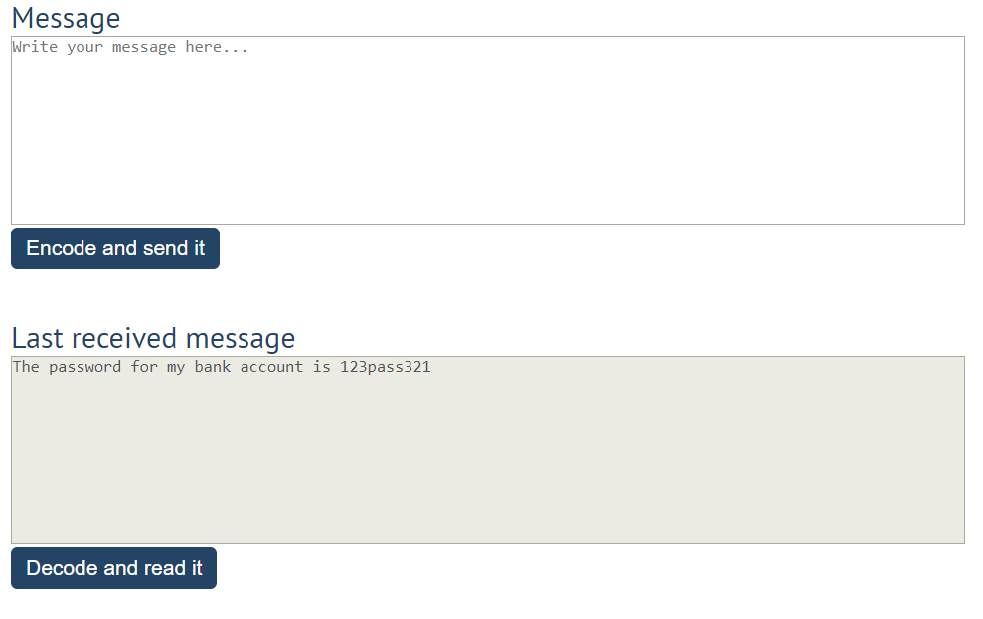

## * Distance Converter

Your task is to convert from **one** distance unit to **another** by adding a **click** event listener to a button. When it is clicked, **read** the value from the input field and **get** the **selected** option from the **input** and **output** units drop downs. Then **calculate** and **display** the converted value in the **disabled** output field.

**Example**

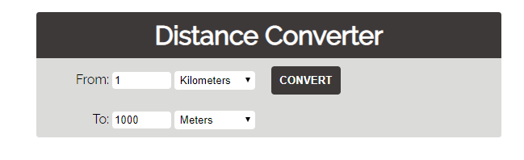

**Hints**

* Multiply the incoming distance by the following conversion rates to convert to meter
* Divide to convert from meters to the required output unit
* To see which option is selected, read the properties of its parent: **value** gives you the value of the selected option (as displayed in the HTML), **selectedIndex** gives you the 0-based index of the selected option. For example, if miles are selected, **inputUnits.value** is "**mi**", **inputUnits.selectedIndex** is **4**. Option text is irrelevant
* Use the following table information to do that:

|  |  |
| --- | --- |
| **1 km** | **1000 m** |
| **1 m** | **1 m** |
| **1 cm** | **0.01 m** |
| **1 mm** | **0.001 m** |
| **1 mi** | **1609.34 m** |
| **1 yrd** | **0.9144 m** |
| **1 ft** | **0.3048 m** |
| **1 in** | **0.0254 m** |